**Blood Drive Site Suitability Guidelines for COVID-19**

**Space Requirements** – Inside areas enabling social distancing, each allowing an area of 6 ft between people. Location on the first floor preferred or dependable elevator access is needed. Can utilize rooms, lobbies, hallways.

* Pre-screening Area - To take temperatures of prospective donors before they enter the blood drive. Typically held in the lobby or a hall directly outside the main room or at the entrance to the main room if space allows.
  + Can be done while donors are in their cars as an alternative.
* Main Room - Minimum of 1200 sq ft. (dependent on drive size), preferably no obstacles (e.g., columns, half-walls)
  + Registration/Queuing Area- Where donors will check in and wait their turn (can be outside of the main room in a hall or lobby if space is a concern)
  + Health History Area
  + Collection Area - Beds spaced 6 feet apart.
  + Recovery/Post Collection Area
  + Canteen Area-where donors rest and have a snack, chairs spaced 6 ft apart

**Amenities**

* Bathrooms close to the donation site on same floor.
* Room specific temperature control – air conditioning and heat.
* Good lighting.
* Minimum of 4 electrical outlets (dependent on drive size)
* 8 Tables and 25 non-permeable, wipeable chairs minimum (dependent on drive size)
* Accessible parking.
* Easy access for unloading of equipment (ramp or dock if needed).
* Wireless - Location will accept wireless equipment. No wireless signal obstructions or impediments.

**Example of Site with Separated Activity Area**

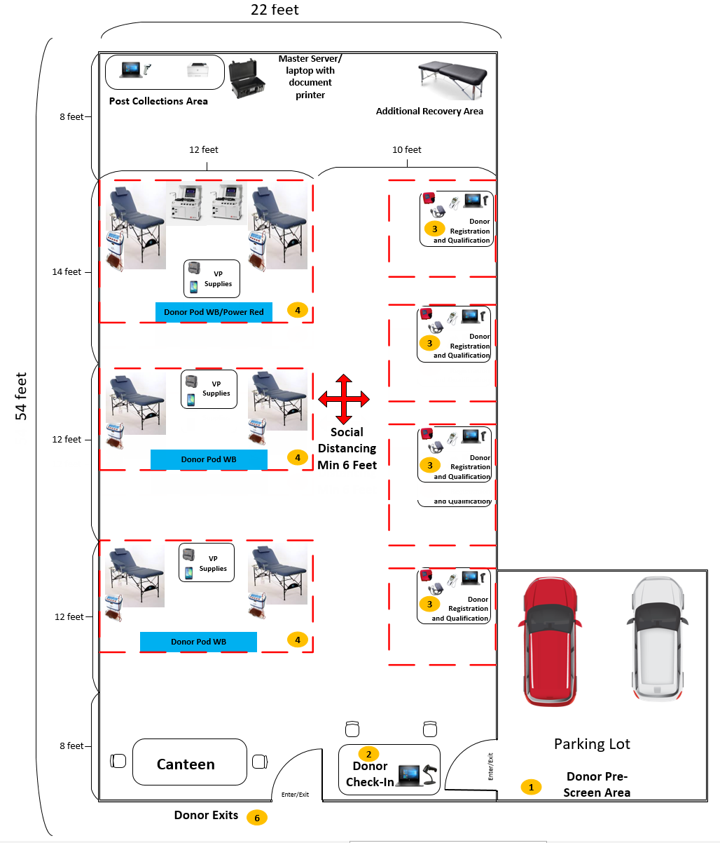Minimum of 1200 sq ft